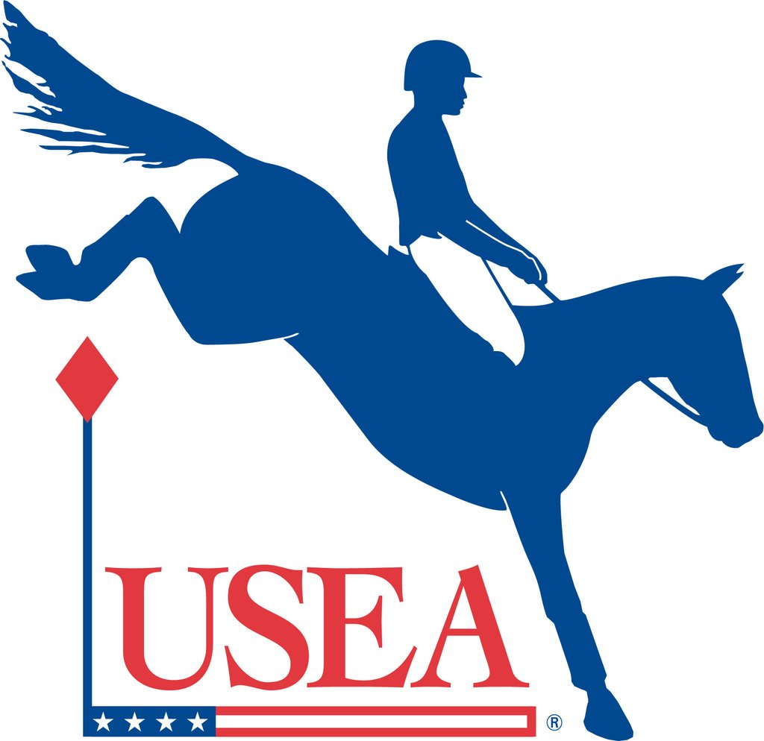

# MINUTES

# USEA Annual Meeting of Members

Sheraton New Orleans, New Orleans, Louisiana

Saturday, December 8, 2018

Call to order (Kozlowski)

Carol Kozlowski began the meeting by inviting Tink Eichell to the podium.

Report of the Secretary (Eichell)

Tink Eichell established a quorum and asked the membership to approve the minutes of the Annual Membership Meeting held December 9, 2017.

A motion was made and seconded to approve the December 9, 2017 meeting minutes.

The motion was passed. There were no oppositions or abstentions.

Report of the President (Kozlowski)

Carol Kozlowski welcomed the membership and acknowledged the efforts of the USEA Board of Governors and staff. She spoke about the decrease in the number of starters, predictions for the 2019 USEA American Eventing Championships in Kentucky and recognized the officials who were the highlight of this year’s convention.

Report of the Treasurer (Thompson)

Morley Thompson provided a report of the financial health of the Association.

Ratification of the Actions of the Board of Governors in 2017 (K. Cooper)

Katherine Cooper explained the ratification process and called for a vote to ratify the actions of the Board.

A motion was made and seconded to ratify the actions of the Board of Governors in 2017.

The motion was passed. There were no oppositions or abstentions.

Report of the CEO (Burk)

Rob Burk began by thanking the USEA staff and acknowledging those with work anniversaries. He presented highlights of 2018 which included achievements of each of the USEA departments.

Recognition of Outgoing Volunteers

Carol Kozlowski honored several outgoing volunteers and presented them with gifts of appreciation.

USEA Foundation Trustee- Katherine Cooper

USEA Foundation Trustee- Dr. Tim Gardner

USEA Foundation Trustee- Kaiti Saunders

Area IV Chair- Kathy Kerns

Area VI Chair- Chris Scarlett

Area IX Chair- Deeda Randle

Board of Governors Member- Bobby Stevenson

Report of the Nominating Committee (K. Cooper)

Katherine Cooper announced the nominees for the Board of Governors who were then voted into office.

Area IX – Deeda Randle

A motion was made and seconded to accept the slate of Board of Governors as a whole.

The motion was passed. There were no oppositions or abstentions.

Katherine introduced the nominees for Trustees of the USEA Foundation.

A motion was made and seconded to accept Roxanne Booth, Vicki Howard-Fine and Alston Kerr as Trustees of the USEA Foundation.

The motion was passed. There were no oppositions or abstentions.

The Governors took a brief recess to nominate officers. Carol Kozlowski presented the slate of officers which was then voted on and accepted by the entire membership.

Carol Kozlowski: President

Max Corcoran: President-Elect

Tink Eichell: Secretary

Morley Thompson, Jr.: Treasurer/ VP Administration and Finance

Mary Coldren: VP Safety

Doug Payne: VP Active Athletes

Jonathan Elliott: VP Competitions

Debra Dealcuaz: VP Area Affairs

Dawn Robbins: VP Membership & Program Development

Jerry Schurink: VP Education

Adjournment (Kozlowski)

The meeting was adjourned at 1:00 pm.