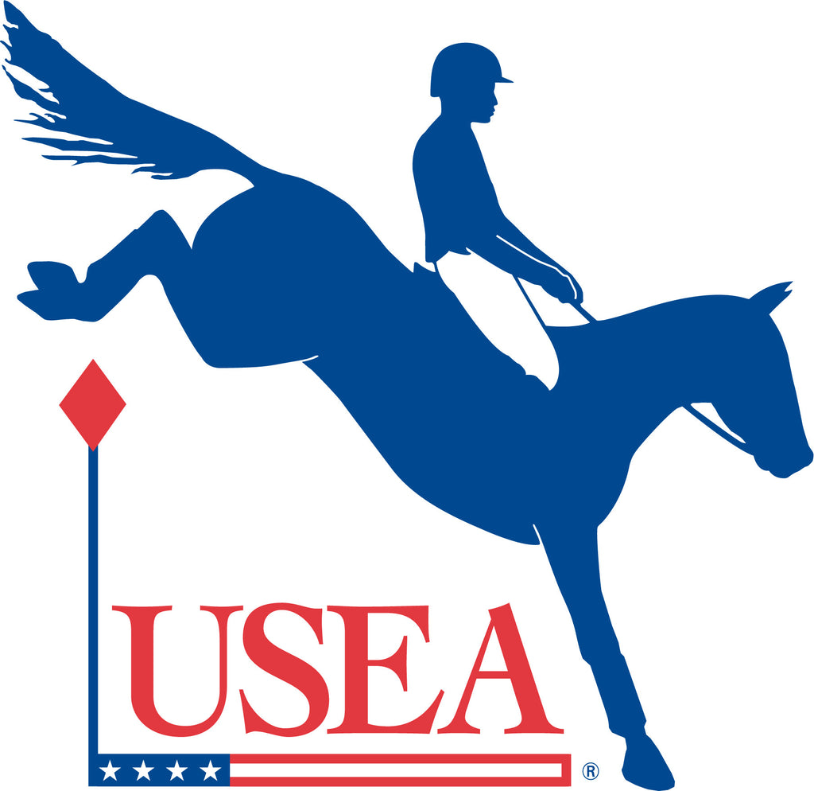

# MINUTES

# USEA Annual Meeting of Members

Hyatt Regency Savannah, Georgia

Saturday December 10, 2022

1. **Call to Order (Corcoran)**

Max Corcoran began the meeting by inviting Sharon Anthony to the podium.

1. **Report of the Secretary (Anthony)**

Sharon Anthony explained the system used for voting.

**A motion was made and seconded to approve the 2021 Meeting of Members minutes.**

*The motion was passed. There were no oppositions or abstentions.*

1. **President’s Report (Corcoran)**

Max Corcoran welcomed everyone to Savannah. She spoke about many successful highlights from several USEA programs and committees as well as the Team USA silver medal won at the World Championships in Italy.

1. **Treasurer’s Report (Murray)**

Brian Murray reported a summary of the 2022 financials. The number of events were slightly down; starters and membership numbers also show declining trends throughout the year which directly impacted the Association’s financial statements. He spoke about the increase in expenses seen after 2020 as business returned to full operations and the Employee Retention Credit approved by the IRS, which will provide about $445,000 early next year.

Hilary Miskoe, USEA Foundation Chair, spoke about the investment portfolio and the reallocation of assets that reflect the purpose of each set of funds; endowment, grants, and USEA Inc. The USET provided a large grant donation to the USEA Foundation for the MARS Bromont Rising Grant Program in honor of Steve Blauner.

1. **Ratification of the Actions of the Board**

**A motion was made and seconded to ratify the 2022 actions of the Board of Governors.**

*The motion was passed. There were no oppositions or abstentions.*

1. **CEO Report (Burk)**

Rob Burk shared many thanks to Max Corcoran for her tremendous leadership as the Association navigated a human pandemic, equine disease outbreak, and many changes and hurdles that faced the Association.

Headquarters Update

Rob Burk reported that the USEA staff level is currently 16 members, which is two less than 2019, and there are plans to hire additional staff in the coming year to increase media and administrative support. This year there was a shift to permanent telework schedules and actions to diversify staff amongst regional locations. The Board of Governors is in discussion about establishing a physical home for the eventing Hall of Fame.

Year in Review

Rob Burk acknowledged that membership and competition numbers are down, however there have been many successful program developments and educational outreach to support our members. The EA21 and Classic Series programs reached record level participation this year.

1. **Thanked Outgoing Volunteers**

Rob Burk recognized and thanked the outgoing Board members Jennifer Miller, Alice Sarno, Morgan Rowsell, and Jerry Schurink, and outgoing Area Chairs Melissa Stubenberg, Barb Crabo, and outgoing USEA Foundation Trustee/Chair Diane Pitts.

1. **2022 Governor’s Cups**

Max Corcoran presented the 2022 Governors Cups, which provides recognition of volunteers whose service has contributed significantly to the sport to Edith Rameika, Shelley Page, Dan Michaels, Janis Linnan, and the ECP Task Force – Jennifer Rousseau, Sharon Anthony, and Joan Simmons.

1. **2022 Andrew H. Popiel Award**

Max Corcoran presented the 2022 Andrew H. Popiel Award to Janet and Glenn Wilson.

1. **Presidential Lifetime Achievement Award**

Max Corcoran presented the 2022 Presidential Lifetime Achievement Award to Jim Wofford.

1. **Report from Nominating Committee (Cooper)**

Katherine Cooper reviewed the 2023 nominating report and introduced the nominees for the Board of Governors.

Area II **Mogie Bearden-Muller** Three-Year Term

Area X **Shawn Ortiz** Three-Year Term

At Large **Dana Bivens** Three-Year Term

At Large **Brian Murray** Three-Year Term

At Large **John Marshall** Three-Year Term

At Large **Molly Pellegrini** Three-Year Term

At Large **Jennifer Rousseau** Three-Year Term

Katherine Cooper introduced the Trustee nominees for the USEA Foundation to be appointed by the Board of Governors.

* **Jonathan Elliott** Three-Year Term
* **Carol Kozlowski** Three-Year Term Reappointment
* **Darrin Mollett** Three-Year Term Reappointment

The Board of Governors excused themselves for a brief recess to complete the vote.

Upon returning to the Meeting of Members, Katherine reported that the Board of Governors unanimously elected the USEA officers for 2023, as well as the trustees of the USEA Foundation. She also introduced the new president of the USEA, Louise Leslie.

Louise Leslie introduced the members of the 2023 Executive Committee:

* + Sharon Anthony: Secretary
  + Rusty Lowe: VP Safety
  + Sharyn Antico: VP Competitions
  + Brian Murray: VP Administration and Finance/Treasurer
  + Lauren Nicholson: VP Active Athletes
  + Deeda Randle: VP Area Affairs
  + John Marshall: VP Membership & Program Development
  + Jennifer Rousseau: VP Education

Louise Leslie recognized the outgoing president Max Corcoran and thanked the members for their dedication and support.

1. **Adjournment (Leslie)**

The meeting adjourned at 1:25pm EST.